A3

PITCHES = 27958m‘

GAMES COURTS = 4481m‘

SOFT INFORMAL and SOCIAL = 52580m*

HARD INFORMAL and SOCIAL = 9483m*
BUILDING FOOTPRINT = 12488m°

ACCESS, PARKING, PATHS and OTHERS = 10587m*

SUPPLEMENTARY NET AREA = 626m*

GROSS SITE AREA = 125681m2

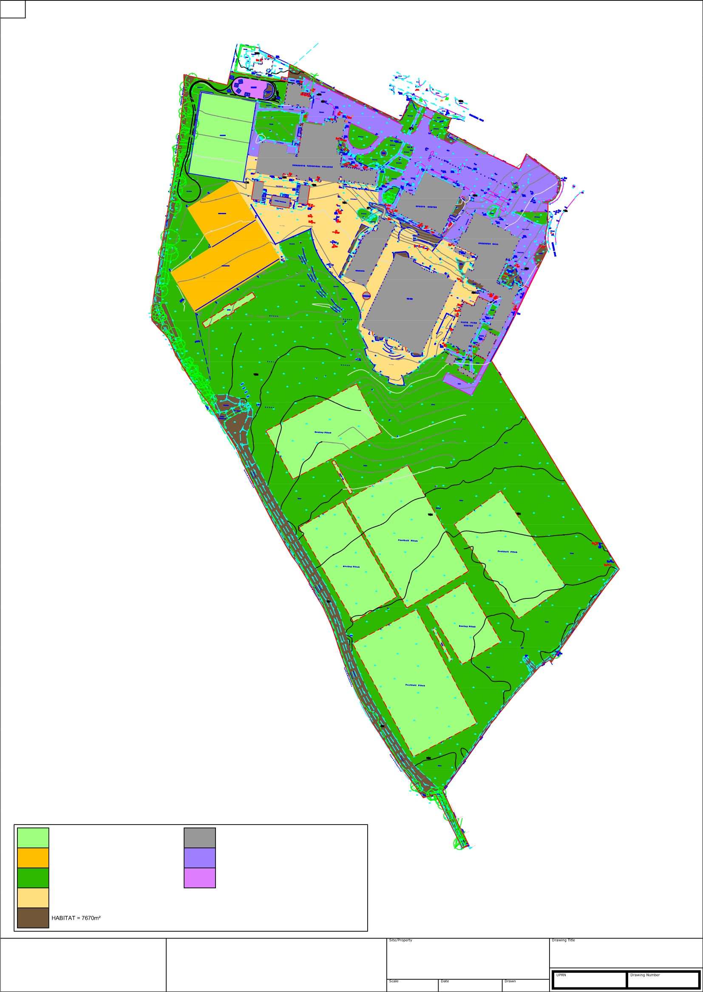

Enabling communities in Dorset to thrive, now and for the future
BUDMOUTH TECHNOLOGY COLLEGE CHICKERELL ROAD
CHARLESTOWN WEYNOUTH
NTS @ A3 Jan 2018
GROSS SITE AREA
Net Capacity Assessment - Jan 2018 Analysis of Areas against BB103

KLT 200000753336 NCA.08

KEY FORMULAE FOR TYPICAL SCHOOL AREAS
BB103: | SITE Area Guidelines for Main Stream Schools |  |  |  |  |  | Form Entry | 9FE + post-16
Typical SITE Area Details for 9FE Secondary School + post-16 |  |  |  |  |  |  | Class Type | Nursery | Primary | Secondary | Post 16
Annex B: Site Areas |  |  |  |  |  |  | Pupil No's | 0 | 0 | 270 | 190
 |  |  |  |  |  |  | Year Grps | 2 | 7 | 5 | 2
Recommended minimum areas for mainstream schools |  | Base area for any: |  | Area per pupil place for: |  |  |  | 0 | 0 | 1350 | 380
 |  | PRIMARY or  Special School | Secondary or Middle School | Nursery | All PRIMARY  Schools | Key Stage 3/4 | Post-16 | 0 | 1350 |  | 380
 |  |  |  |  |  |  |  | 1730
1. Soft Outdoor PE |  |  | 6000 |  | 20 | 35 | 35 | 66550
2. Hard Outdoor PE |  | 400 | 400 |  | 1.5 | 1.5 | 1.5 | 2995
3. Soft Informal & Social Area |  | 600 | 600 | 2 | 2 | 2 | 2 | 4060
4. Hard Informal & Social Area |  | 200 | 200 | 1 | 1 | 1 | 1 | 1930
Habitat |  | 0 | 0 | 0 | 0.5 | 0.5 | 0.5 | 865
Float |  | 600 | 800 | 2 | 5 | 5 | 5 | 9450
Minimum Net SITE area |  | 1800 | 8000 | 5 | 30 | 45 | 45 | 85850
Non-net area | Building Footprint | 350 | 2000 | 1 | 3.3 | 5 | 5 | 10650
 | Access, Parking, Paths, etc
Minimum Gross SITE area |  | 2000 | 9000 | 6 | 33.3 | 50 | 50 | 95500
Recommended maximum SITE areas for NEW mainstream schools (minimum for existing Schools where available)
Maximum net area |  | 2000 | 9000 | 6 | 33.3 | 50 | 50 | 95500
Maximum gross area |  | 2400 | 11000 | 7.5 | 42 | 63 | 63 | 119990

EXISTING SITE SURVEY MEASURED AREAS | Analysis of existing site measurements for  BUDMOUTH (9FE) SECONDARY SCHOOL  [ inclusive of post-16 ]  as compared to recommended minimum site areas contained within Annex B of BB103 guidelines
9FE  + post-16 | Please Reference Drawing NCA 04  Analysis of existing Site Areas against BB103 minimum recommendations
1730
27958 | -38592 | area in deficit when compared against BB103 Guidelines
4481 | 1486 | area in surplus when compared against BB103 Guidelines
52580 | 48520 | area in surplus when compared against BB103 Guidelines
9483 | 7553 | area in surplus when compared against BB103 Guidelines
7670 | 6805 | area in surplus when compared against BB103 Guidelines
626 | -8824 | area in deficit when compared against BB103 Guidelines
102798 | 16948 | Surplus NET Area when compared to BB103 recommended minimum NET site areas
12488  10587 | area of existing building footprints
 | area of existing access, parking, paths, etc.
125873 | 30373 | Surplus GROSS Area when compared to BB103 recommended minimum GROSS site areas
102798 | 7298 | Surplus NET Area when compared to BB103 recommended maximum NET site areas
125873 | 5883 | Surplus GROSS Area when compared to BB103 recommended maximum GROSS site areas

All age above 750 places, or with more than about 300 11 to 16 places, should use the total of the primary and secondary base areas.
School's Published PAN = 260 pupil places
Total planned admission capacity PAC: 1300 total pupil places

Recommended site areas for all types of schools
Note: The net area includes a ‘float’. When the recommended minimum areas of each category of space are added together, the total will be less than the recommended total net area. This difference provides the ‘float’ that can be used to enhance some areas,
Where there is limited outdoor space available to pupils on a restricted site, consideration should be given to providing the following:
- firstly, hard informal and social area, including outdoor play area immediately accessible from early years classrooms;
- then hard outdoor PE space, ideally in the form of a multi-use games area;
- then soft informal and social area;
- finally soft outdoor PE area.

